News
A new registration possibility is available for those not able to be here on September: Live streaming conferences, that includes 15 live streaming conferences to take place during the Congress.
For Spanish students, please make a special effort in your Final Degree Work as the three best of every Faculty will be awarded with a free registration and accommodation during the Conference.
Do not forget that all Pharmacy Faculty Deans of Spain will have a meeting here to discuss the present and future problems of pharmaceutical studies and update possible solutions.

Rem
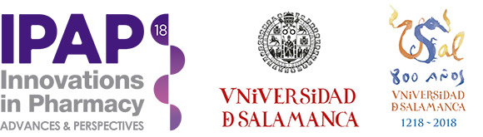

SECRETARÍA TÉCNICA:
Fundación General de la Universidad de Salamanca
Hospedería del Colegio Fonseca
c/ Fonseca 2, 37002 Salamanca
Tel.: 923 294 679
ipap18@usal.es
https://ipap18.org/

